Haverhill Public Schools
2023 Suggested Summer Reading Lists Grades 4-8
*All of these suggested books are available at the Haverhill Public Library

Grade 4
Fiction
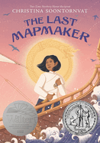The Last Mapmaker by Christina Soontornvat
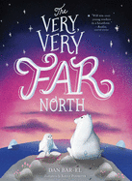 Very, Very Far North by Dan Bar-El
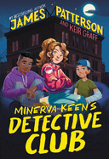Minerva Keene’s Detective Club by James Patterson and Keir Graff
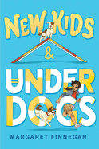 New Kids and Underdogs by Margaret Finnegan
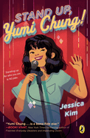Stand Up, Yumi Chung by Jessica Kim
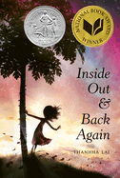Inside Out and Back Again by Thanhha Lai
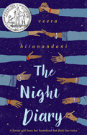
The Night Diary by Veera Hiranandani
Graphic Novels
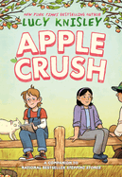Apple Crush by Lucy Knisley
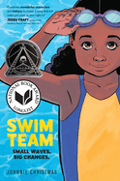Swim Team by Johnnie Christmas
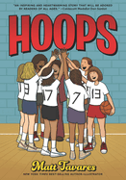Hoops by Matt Tavares
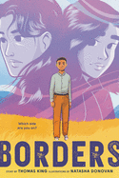Borders by Thomas King
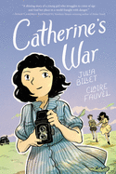Catherine’s War by Julia Billet
Nonfic
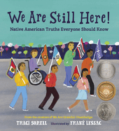We Are Still Here! Native American Truths Everyone Should Know by Traci Sorell
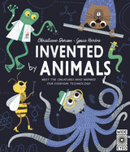Invented Animals by Christiane Dorian
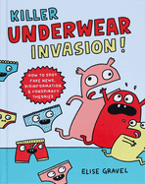Killer Underwear Invasion! : How to Spot Fake News, Disinformation & Conspiracy Theories by Elise Gravel
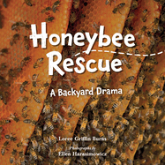Honeybee Rescue: A Backyard Drama by Loree Griffin Burns
Series
- Survivor Diaries by Terry Lynn Johnson
- Blast Back by Nancy Ohlin
- Where in the World Can I…
- Ayo’s Awesome Adventures

Grade 5
Fiction
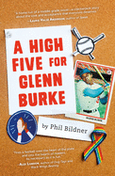A High Five for Glenn Burke by Phil Bildner
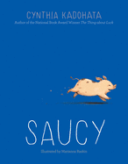Saucy by Cythia Kadohata
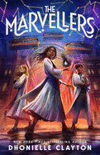The Marvellers by Dhonielle Clayton
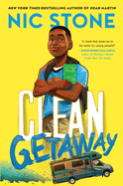Clean Getaway by Nic Stone
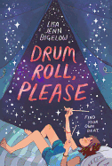Drum Roll, Please by Lisa Jenn Bigelow
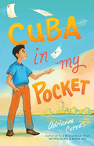Cuba in my Pocket by Adrianna Cuevas
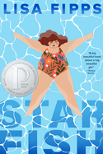Starfish by Lisa Fipps
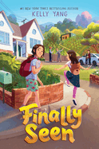Finally Seen by Kelly Yang
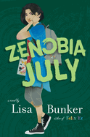Zenobia July by Lisa Bunker
Graphic Novels
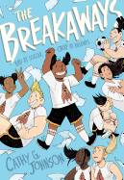 The Breakaways by Cathy G. Johnson
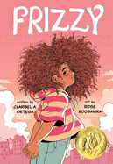Frizzy by Claribel Ortega
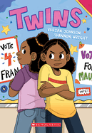Twins by Varian Johnson
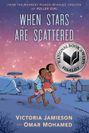When the Stars are Scattered by Victoria Jamieson
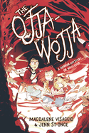The Ojja-Wojja by Magdalene Visaggio
Nonfiction
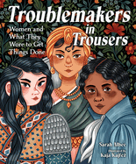Troublemakers in Trousers by Sarah Albee
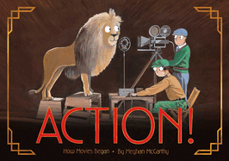Action! How Movies Began by Meghan McCarthy
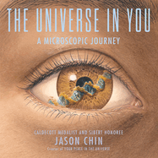The Universe in You: A Microscopic Journey by Jason Chin
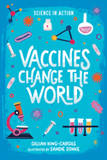Vaccines Change the Wold by Gillian King-Cargile
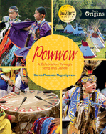Powwow: A Celebration Through Song and Dance by Karen Pheasant-Neganigwane
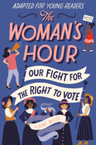The Woman’s Hour Our Fight for the Right to Vote by Elaine Weiss

Series
- Nathan Hale’s Hazardous Tales by Nathan Hale
Grade 6
Fiction
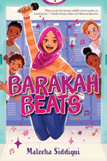Barakah Beats by Maleeha Siddiqui
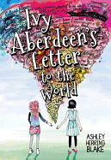 Ivy Aberdeen’s Letter to the World by Ashley Herring Blake
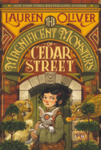The Magnificent Monsters of Cedar Street by Lauren Oliver
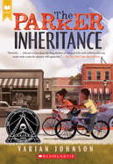The Parker Inheritance by Varian Johnson
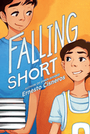Falling Short by Ernesto Cisneros
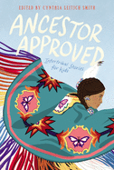Ancestor Approved by Cynthia L. Smith
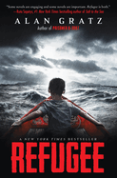Refugee by Alan Gratz
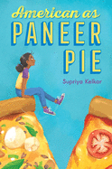American as Paneer Pie
Graphic Novels
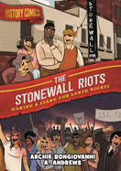The Stonewall Riots: Making a Stand for LGBTQ Rights by Archie Bongiovanni (also a series)
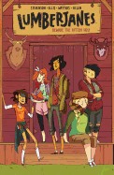Lumberjanes by ND Stevenson
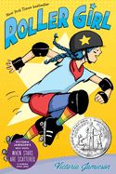Roller Girl by Victoria Jamieson
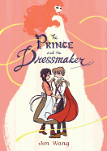 The Prince and the Dressmaker by Jen Wang
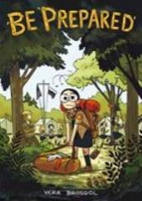Be Prepared by Vera Brosgol
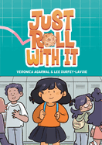Just Roll With It by Veronica Agarwal
(series)
Nonfiction
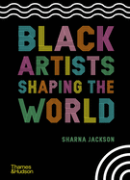Black Artists Shaping the World by Sharna Jackson
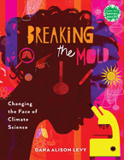Breaking the Mold by Alison Dana Levy
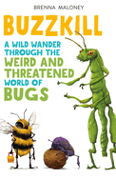Buzzkill: A Wild Wander Through the Weird and Threatened World of Bugs by Brenna Maloney
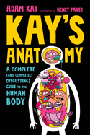Kay’s Anatomy: A Complete (and Completely Disgusting) Guide to the Human Body by Adam Kay
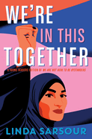We’re In This Together: Young Readers Edition of We Are Not Here to be Bystanders
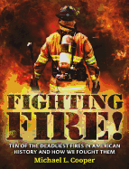Fighting Fire! Ten of the Deadliest Fires in American History and How We Fought Them By Michael L. Cooper
Grade 7
Fiction
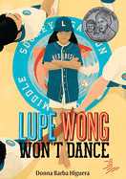Lupe Wong Won’t Dance by Donna Barba Higuera
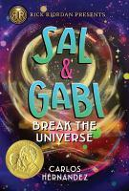Sal and Gabi Break the Universe by Carlos Hernandez
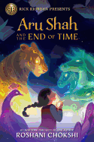Aru Shah and the End of Time by Roshani Chokshi
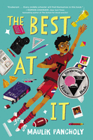The Best At It by Maulik Pancholy
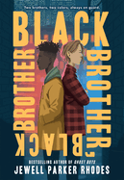Black Brother, Black Brother by Jewell Parker Rhodes
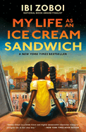My Life as an Ice Cream Sandwich by Ibi Zoboi
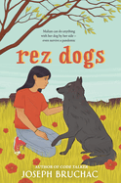Rez Dogs by Joseph Bruchac
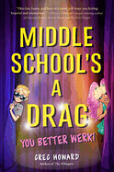Middle School’s a Drag, You Better Work by Greg Howard
Graphic Novels
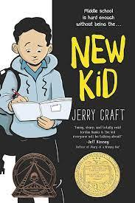New Kid by Jerry Craft
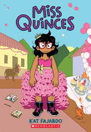Miss Quinces by Kat Fajardo
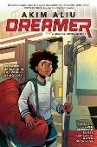Akim Aliu: Dreamer by Akim Aliu
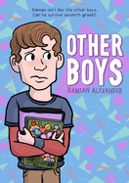Other Boys by Damian Alexander
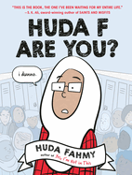Huda F Are You? By Huda Fahmy
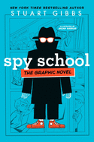Spy School by Stuart Gibbs
Nonfiction
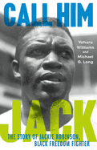Call Him Jack: The Story of Jackie Robinson, Black Freedom Fighter by Yohuru Williams.
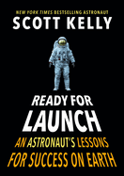Ready for Launch: An Astronaut’s Lessons For Success on Earth by Scott Kelly
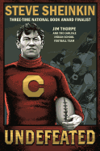Undefeated: Jim Thorpe and the Carlisle Indian School Football Team by Steve Sheinkin
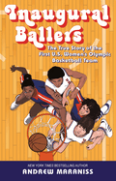Inaugural Ballers: The True Story of the First US Women’s Olympic Basketball Team
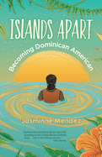Islands Apart: Becoming Dominican American by Jasminne Mendez
Grade 8
Fiction
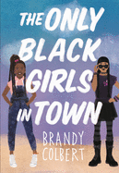The Only Black Girls in Town by Brandy Colbert
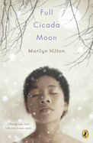Full Cicada Moon by Marilyn Hilton
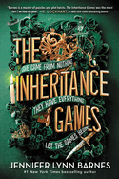The Inheritance Games by Jennifer Lynn Barnes
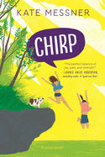Chirp by Kate Messner
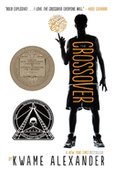The Crossover by Kwame Alexander
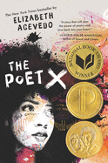The Poet X by Elizabeth Acevedo
Graphic Novels
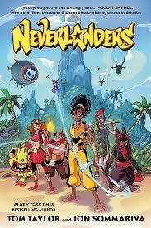Neverlanders by Tom Taylor
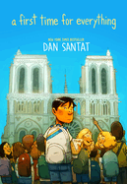A First Time for Everything by Dan Santat
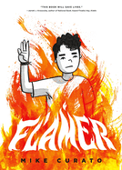Flamer by Mike Curato
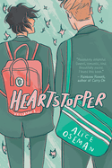Heartstopper by Alice Oseman
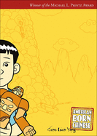American Born Chinese by Gene Luen Yang
Nonfiction
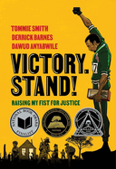 Victory. Stand! Raising My Fist for Justice by Tommie Smith
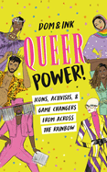Queer Power! Icons, Activists & Game Changers Across the Rainbow by Dom & Ink
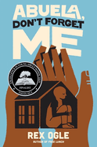Abuela, Don’t Forget Me by Rex Ogle
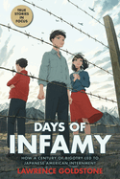Days of Infamy: How a Century of Bigotry Led to Japanese American Internment by Lawrence Goldstone
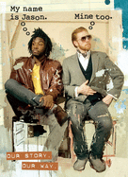My Name is Jason. Mine Too. : Our Story. Our Way. By Jason Reynolds and Jason Griffin
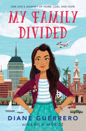My Family Divided by Diane Guerrero

