Are you struggling financially or emotionally or know someone who is ?
Do you want to learn more about the numerous services available in our city? THERE IS HELP AVAILABLE !!
Please join us Wednesday, May 18, 2022 at the Citizens Center
11a -3pm at 10 Welcome Street , Haverhill, MA
Representatives from local organizations who are attending include:
-Job Assistance , Adult Education and Training Resources
-Affordable Housing
-Substance Abuse and Mental Health Counseling Services
-Transportation
-Food and Clothing
-Heating and Fuel Assistance
-Youth Services and Programs for Adults with Disablities
-Moderna and Flu Vaccines
AND MANY MORE !
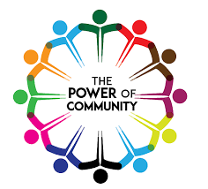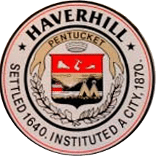

Sponsored by the City of Haverhill Public Health Department 10 Welcome Street, Haverhill , MA. 01830 (978) 374-2390 x 3900

